what is laravel ?

Laravel is a framework of php

Laravel make a dynamic web applications or website in php

Laravel support MVC architecture

Model:model used database connections

View :view are load templates or UI

Conmtroller:controllers create a business logic of our applicatrions

MVC architecture :

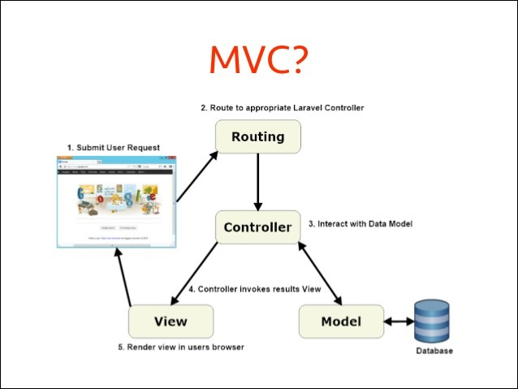

Laravel is a framework it meanse provides its own structure

Laravel is support advanced php or php 8.0 or > version of php8.0

Laravel9.0 version the it is support php 8.1 or > 8.1

Testing version of php :

<http://localhost/xampp/>

Apache/2.4.53 (Win64) OpenSSL/1.1.1n PHP/8.1.6 Server at localhost Port 80

Laravel if created a large scale types of website of web applications.

Laravel support all database and it is open source.

Laravel support all operating systems

Laravel support all server tools also

Xampp | wamp | lamp

Laravel provides more security to create a secured web applications

Examples :

oops support

Laravel support service providers and service containers

Laravel provides to protect from hacker of our form data using @csrf token

**Advantage of laravel :**

Laravel is framework of php

Laravel create secured website

Laravel protects form data using @csrf_token

Laravel support mvc.

Laravel support unit testing .

Laravel support seo friendly websites

Laravel support default .htaccess file

Laravel provides blade template engine to load view

Examples : index.blade.php

Contact.blade.php

Feedback.blade.php

Laravel provides ORM (object relational mapping) elequent query builder model to performed or write SQL queries.

Examples : sql : insert into tablename(columnsname) values(‘values’);

Laravel : Modelname::create(data);

Laravel provides database migrations to create tables schema or structure inside of laravel.

Examples : php artisan serve

php artisan make:migration create_users_table

Php artisan list

Laravel provides to write any commands a **php artisan**  this is a command line interface of laravel to create a structures.

**How to install laravel 9.0**

**Step 1 :** download composer

**Step 2 :**check composer is installed or not

composer

**Step 3 :**install laravel or create a app in laravel

composer create-project laravel/laravel:9.0.* appname or projectname

**Step 4 :** run laravel

Php artsian serve

<http://127.0.0.1:8000/>

**Note :what is composer ?**

Composer is a dependency manager to help to install or create a laravel projects and its packages and libraries.

<https://getcomposer.org/>

D:\xampp\htdocs\php-9am-tts\module6\laravel-installation>composer

______

/ ____/___ ____ ___ ____ ____ ________ _____

/ / / __ \/ __ `__ \/ __ \/ __ \/ ___/ _ \/ ___/

/ /___/ /_/ / / / / / / /_/ / /_/ (__ ) __/ /

\____/\____/_/ /_/ /_/ .___/\____/____/\___/_/

/_/

Composer version 2.8.1 2024-10-04 11:31:01

Install laravel app :

Coomands : composer create-project laravel/laravel:9.0.* ecommerceapp

How to run laravel projects

D:\xampp\htdocs\php-9am-tts\module6\laravel-installation\ecommerceapp>php artisan serve

INFO Server running on [http://127.0.0.1:8000].

Press Ctrl+C to stop the server

**Laravel avialable commands**

**php artisan list**

Available commands:

about Display basic information about your application

clear-compiled Remove the compiled class file

completion Dump the shell completion script

db Start a new database CLI session

docs Access the Laravel documentation

down Put the application into maintenance / demo mode

env Display the current framework environment

help Display help for a command

inspire Display an inspiring quote

list List commands

migrate Run the database migrations

optimize Cache the framework bootstrap files

serve Serve the application on the PHP development server

test Run the application tests

tinker Interact with your application

up Bring the application out of maintenance mode

auth

auth:clear-resets Flush expired password reset tokens

cache

cache:clear Flush the application cache

cache:forget Remove an item from the cache

cache:table Create a migration for the cache database table

config

config:cache Create a cache file for faster configuration loading

config:clear Remove the configuration cache file

db

db:monitor Monitor the number of connections on the specified database

db:seed Seed the database with records

db:show Display information about the given database

db:table Display information about the given database table

db:wipe Drop all tables, views, and types

env

env:decrypt Decrypt an environment file

env:encrypt Encrypt an environment file

event

event:cache Discover and cache the application's events and listeners

event:clear Clear all cached events and listeners

event:generate Generate the missing events and listeners based on registration

event:list List the application's events and listeners

key

key:generate Set the application key

make

make:cast Create a new custom Eloquent cast class

make:channel Create a new channel class

make:command Create a new Artisan command

make:component Create a new view component class

make:controller Create a new controller class

make:event Create a new event class

make:exception Create a new custom exception class

make:factory Create a new model factory

make:job Create a new job class

make:listener Create a new event listener class

make:mail Create a new email class

make:middleware Create a new middleware class

make:migration Create a new migration file

make:model Create a new Eloquent model class

make:notification Create a new notification class

make:observer Create a new observer class

make:policy Create a new policy class

make:provider Create a new service provider class

make:request Create a new form request class

make:resource Create a new resource

make:rule Create a new validation rule

make:scope Create a new scope class

make:seeder Create a new seeder class

make:test Create a new test class

migrate

migrate:fresh Drop all tables and re-run all migrations

migrate:install Create the migration repository

migrate:refresh Reset and re-run all migrations

migrate:reset Rollback all database migrations

migrate:rollback Rollback the last database migration

migrate:status Show the status of each migration

model

model:prune Prune models that are no longer needed

model:show Show information about an Eloquent model

notifications

notifications:table Create a migration for the notifications table

optimize

optimize:clear Remove the cached bootstrap files

package

package:discover Rebuild the cached package manifest

queue

queue:batches-table Create a migration for the batches database table

queue:clear Delete all of the jobs from the specified queue

queue:failed List all of the failed queue jobs

queue:failed-table Create a migration for the failed queue jobs database table

queue:flush Flush all of the failed queue jobs

queue:forget Delete a failed queue job

queue:listen Listen to a given queue

queue:monitor Monitor the size of the specified queues

queue:prune-batches Prune stale entries from the batches database

queue:prune-failed Prune stale entries from the failed jobs table

queue:restart Restart queue worker daemons after their current job

queue:retry Retry a failed queue job

queue:retry-batch Retry the failed jobs for a batch

queue:table Create a migration for the queue jobs database table

queue:work Start processing jobs on the queue as a daemon

route

route:cache Create a route cache file for faster route registration

route:clear Remove the route cache file

route:list List all registered routes

sail

sail:add Add a service to an existing Sail installation

sail:install Install Laravel Sail's default Docker Compose file

sail:publish Publish the Laravel Sail Docker files

sanctum

sanctum:prune-expired Prune tokens expired for more than specified number of hours.

schedule

schedule:clear-cache Delete the cached mutex files created by scheduler

schedule:list List all scheduled tasks

schedule:run Run the scheduled commands

schedule:test Run a scheduled command

schedule:work Start the schedule worker

schema

schema:dump Dump the given database schema

session

session:table Create a migration for the session database table

storage

storage:link Create the symbolic links configured for the application

stub

stub:publish Publish all stubs that are available for customization

vendor

vendor:publish Publish any publishable assets from vendor packages

view

view:cache Compile all of the application's Blade templates

view:clear Clear all compiled view files

**Laravel projects directory systems**